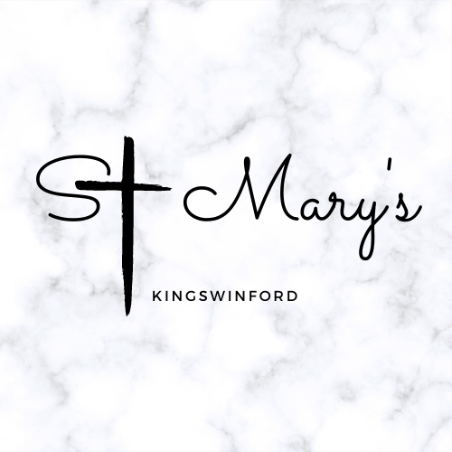

Sunday 27th July 2025

Newsletter

**Priest in Charge - Fr Adam Hadley**

[fr.adam@stmaryskingswinford.org.uk](mailto:fr.adam@stmaryskingswinford.org.uk)

07759 900947

**Mission Priest - Mthr Sarah Roberts-Malpass**

[Mthr.sarah@stmaryskingswinford.org.uk](mailto:Mthr.sarah@stmaryskingswinford.org.uk)

07976 965275

**Curate - Fr Chris Smith**

[fr.chris@stmaryskingswinford.org.uk](mailto:fr.chris@stmaryskingswinford.org.uk)

07562 949395

**Children, Youth and Family Minister and**

**Parish Safeguarding Officer - Sian Morgan**

[sian@stmaryskingswinford.org.uk](mailto:sian@stmaryskingswinford.org.uk)

07729 092972

**Parish Administrator - Lindsey Poulding**

[office@stmaryskingswinford.org.uk](mailto:office@stmaryskingswinford.org.uk)

07729 092973

**Operations Manager - Grace Wrigglesworth**

[operations@stmaryskingswinford.org.uk](mailto:operations@stmaryskingswinford.org.uk)

07562 955888

**Church Wardens**

Helen Moren 01384 270757

Neil Oliver 07720 783330

**Pray for our sick** and those who care for them: Louise, Helen, Ken, Angela, Mike Roberts, Rev'd Claire Lording, Pat Orme, Tony, Denise, Harold, Kirsty, Justin, Jill, Jodie, Ruth, Jill Nicholls, Chris Knight.

**ST MARY’S SERVICES – JULY/AUGUST**

**Sunday 27 July**

**10am Morning Prayer**

**12.30pm Baptisms**

**6.30pm Memorial Service**

**Monday 28 July**

**8.30am Morning Prayer**

**Tuesday 29 July**

**8.30am Morning Prayer**

**10am Midweek Said Eucharist**

**Wednesday 30 July**

**8.30am Morning Prayer**

**Sunday 3 August**

**10am Sung Eucharist**

**All are welcome to Evening Prayer at Church of the Ascension**

**at 5pm on Monday, Tuesday and Wednesday this week**

**Recently Departed**: Harry Houghton, Melvyn Bailey, Irene Bishop, Martyn Wassell.

**Year’s Mind**: Arthur Stevens, Bernard Holden, Glyn Clarke, Harry Morris, Jeffrey Mole, Benjamin Baker, Elsie Cadman, Barbara Holyoake, Edna Hayward, Brian Neate,

Maureen Hodgkins, Joseph Wiltshire, Frank Lloyd.

***Please pray for the people that live in Castlewellan Care Home in our parish and for the people who care for them.***

**Fr. Mel’s Prayer Meeting**

The next meeting will be on **Monday August 4th at 7.00pm.** Venue to be announced.

**Please email any notices and items for this weekly newsletter to Lindsey in the parish office by Thursday for printing on Fridays. Thank you.**

[**office@stmaryskingswinford.org.uk**](mailto:office@stmaryskingswinford.org.uk)

**Eucharist Assistants**

As you know each Sunday people accompany the priest to distribute Communion.  It’s usually the chalice but can also be the bread.  Have you ever thought about you having this ministry of faithful service?  If you have, speak to one of the priests and we can discern with you whether this is something you’re called to do.  Full training will be given and we’ll need to do a little bit of safeguarding work with you but this is a really important part of our church life together and I commend to your prayers whether this is something you, or someone else you know might be called to.

**St Mary’s next Community Coffee Morning** is on **Thursday 8th September 10-12.** Held on the 2nd and 4th Thursday of the month. Everyone very welcome!

**Singing for Pleasure “Musical Memories” Summer Concert** is being held at Church of the Ascension on **Saturday 26th July at 7.30pm.** Tickets including light refreshments are £5 available from Floss Jepson on 07534 491331.

**The Memorial Service at St Mary’s**

Is this **Sunday 27th July at 6.30pm**. Everyone is welcome.

**St Mary’s Patronal Festival is on Sunday 7 September.** We will have a team service at St Mary’s to celebrate it’s patronal festival.

**Please note this will start at 11am (not 10am) followed by lunch.**

Our guest preacher for the day if the Diocesan Secretary Fr Andy Todd.

**Baptisms** We will be baptising 8 of our Iranian friends as part of our morning worship at COA on Sunday 10th August at 10am, followed by a bring and share lunch.

**July 50/50 Draw Winners**

Congratulations to this month's winners: 1st Prize £20 - no.66 Graham Follos & 3 x runners up @ £10 - no.45 Martin Tranter, no.56 Adele Hurst & no.68 George Pemberton.

**PARISH DEVELOPMENT**

Things are hotting up!! The new toilets are wonderful at St Mary’s and those at

The Ascension are well on their way to completion!

**SO, now’s the time to SIGN UP** **FOR THE PARISH DEVELOPMENT HOUSE GROUPS THAT WILL MEET IN SEPTEMBER.**

**Times and venues are:**

* **Monday evenings at Fr Mel’s beginning at 7.30pm**
* **Tuesday afternoons at Sheila Gregg’s beginning at 2.30pm**
* **Thursday afternoons at Jane Freeman’s beginning at 2.30pm**
* **Thursday evenings at Sue Brown’s beginning at 7.30pm**

The various addresses are on the sign-up sheets.

**The future is God’s and ours – your opinion matters!**

***Sixth Sunday After Trinity***

***Collect***

Creator God, you made us all in your image:

may we discern you in all that we see, and serve you in all that we do;

through Jesus Christ our Lord. **Amen.**

***Today’s Readings Hymns***

Hosea 1: 2-10 702 – Lead us heavenly father, lead us

Psalm 85 629 – Father, hear the prayer we offer

Colossians 2: 6-19 116 – Be thou my guardian and my guide

Luke 11: 1-13 581 – Lord of Lords and King eternal

***Post Communion***

God of our pilgrimage, you have led us to the living water:

refresh and sustain us as we go forward on our journey,

in the name of Jesus Christ our Lord. **Amen.**

***Baptism Preparation – Prayer for July***

*Creator God bless these parents and give them the strength and patience to nurture their family, so that they can become a kind and caring family*. **Amen.**

***Book:*** *Miss Dose the doctor’s daughter*

**Gluten Free Wafers - whenever the Eucharist is celebrated gluten free wafers will be available from the communion station in the Lady Chapel.**

Copyright Information Common Worship: Services and Prayers for the Church of England (2000), New Patterns for Worship (2002) and Common Worship. Times and Seasons (2006) material from which is included in this service is copyright © The Archbishop’s Council Music & song words reproduction, music performance and the playing of recorded music is carried out under the terms of our licenses with Christian Copyright Licensing International Ltd. Church License no. 1040738, other license numbers available on request.